Upcoming Events …
February Events:

- Line Dancing at Blue Arrow Farm: 83 Glenwood Rd, Pine Island, NY 10969-1639. Saturday, February 17th, 2024, at 6pm-9pm. We welcome everyone from first timers to experienced dancers to come out and dance with us.
The door opens and a meet and greet with Courtney begins at 6pm, with food and drinks available. The dancing starts at 7pm!
No age limit. Tickets will be $10 at the door — Save $2 by buying online!

- Mac & Cheese Mayhem: Located at the Morristown Armory/430 Western Ave, Morristown, NJ 07Saturday, February 24th, 2024, 11am-7pm. comfort-food-filled-family-fun day with various other activities including music, beer, margaritas & sangria, hatchet throwing, petting zoo, face painting, sand art, inflatables, lots of great vendors & kid’s activities. $7 admission for pre-purchased tickets. Advanced purchase tickets are recommended.
Food vendors will be selling small plates, so come as a group and taste all the mouthwatering, cheesy goodness, and vote for your favorite. This is an indoor event...rain or shine. Open to the public.

- Chunky Knit Blanket at Jersey Girl Brewing: 426 Sand Shore Rd, Hackettstown, NJ 07840. Sunday, February 25, 2024, at 2pm-5pm. **During this one-of-a-kind event, we will guide you step-by-step through hand knitting a warm, soft chunky knit blanket. No needles or knitting experience is required and all supplies will be provided. We are on the road for an awesome night at Jersey Girl Brewing! Join us to create a Chunky Knit Blanket while enjoying a beer or hard seltzer (one included with event cost; additional drinks may be purchased in the Tasting Room). Please note, you are welcome to bring snacks, but outside alcohol is NOT permitted.
Our Chunky Knit Blanket session will be run in an "open color" format...this means you will choose your colors when you get to Jersey Girl Brewing on a first come, first serve basis. We'll have a variety of neutral colors available, and you are welcome to mix and match (subject to availability)! Doors will open at 1:45PM---no early birds, please! These throw blankets measure approximately 40" x 50" upon completion.
Cancellation Policy: **NO REFUNDS, CREDITS, OR RESCHEDULES will be issued for reservations!

March Events:
- Kids Night Out: YMCA Via Calton Village, Hamburg, NJ 07419. Friday, March 1st, 2024, 6pm-8pm. This is a great opportunity for parents to enjoy a night out while their children have a safe and fun night with their friends at the Y. Kids will enjoy swimming, games, arts, crafts and more.
- David Nail performing at the Newtown Theater: 234 Spring St, Newton, NJ 07860. Friday, March 1st, 2024, at Doors open at 7pm show starts at 8pm.

- Sparta High School Presents: The Wizard of Oz: Sparta High School/70 West Mountain Rd, Sparta, NJ 07871. March 1st and March 2nd Shows start at 7pm, on March 3rd the show starts at 2pm.

- Country Line Dancing: Jersy Girl Brewing Company/426 Sand Shore Rd, Hackettstown, NJ 07840. Saturday, March 2nd, 2024, starts at 6:30pm. Grab your friends and dancing boots for an amazing night of dancing. Lessons with Country Fusion with Kristin. 21 years or older, No cover charge.

- 3rd Annual Beefsteak Dinner & Tricky Tray: Beemerville Fire Company/ 227 Country Rd 519, Sussex, NJ 07461. Saturday, March 2nd, 2024, starts at 5pm. * Tickets available as of 12/3, get yours today! Email hpjrwildcatsfootball@gmail.com to purchase! $65 per person includes admission, 1 tricky tray ticket bundle, traditional Beefsteak dinner, soda & beer. Cash bar available. Cash, check, Venmo accepted.
Currently accepting Tricky Tray donations. Must be 21 or older to attend.

- Vernon Vipers Baseball Tricky Tray: Saturday, March 9th, 2024. Tricky Tray to support the 14U Vernon Vipers Baseball Team! Doors open at 5:00pm calling starts 7:00pm ADULTS ONLY NO ONE UNDER 18 Admission $1.00 Bundles $45 Presale Bundles $35 (save $10) Bundles include: 5 regular sheets/5 specials/3 super specials

- St. Patrick’s Day Parade: 218 Spring St, Newton, NJ 07860. Saturday, March 16th, 2024, starts at 11m.

- Hollywood Nights Tricky Tray: 904 Stillwater Rd, Stillwater, NJ 07875. Friday, March 22nd, 2024. Doors open at 5pm.

- Branchville Hose Company Tricky Tray: 1 Railroad Ave, Branchville, NJ 07826. Friday March 22nd, 2024, Doors open at 6pm and Drawing begins at 8pm.

- Special Needs Resource Fair & Family Fun Day: 1033 Springfield Ave, Cranford, NJ 07016. Saturday, March 23rd, 2024, 11am-1pm. More than 50 special needs resources come together with superheroes and games for a day of family fun and networking.

- TNWF Tricky Tray: Centenary University/ 400 Jefferson St, Hackettstown, NJ 07840. Saturday, March 23rd, 2024, Doors open at 4pm and calling starts at 6pm. *You MUST be at least 18 years of age to attend. Registration is due by Saturday, March 9, 2024. FEARLESS Bundle is Optional: $75.00 ~ Save $45 by purchasing a FEARLESS ticket bundle in advance. You’ll receive $120 worth of tickets for all 4 prize tiers for just $75 when purchased with registration by March 9th
. FEARLESS bundles will be sold at the event for $100. **THE FEARLESS BUNDLE DOES NOT INCLUDE ADMISSION** Admission tickets and FEARLESS bundles will be held at check in (by last name) for your convenience. Please e-mail nick8wevents@gmail.com with any questions or if you would like to donate a prize.

- Free Days at the Zoo: The Bronx Zoo/ 2300 Southern Blvd, Bronx, NY 10460. Wednesday, Marh 27th, 2024, 10am 5pm. Limited admission is free all day on Wednesdays at the Bronx Zoo. ADVANCE TIMED TICKETS ARE REQUIRED. The Wednesday Ticket Store will open on Monday at 5:00pm for that Wednesday’s reservations. DO NOT come to the zoo without a reserved ticket. Get FREE tickets ➜ bit.ly/freezooticketz If you prefer to buy tickets instead: tinyurl.com/bzootix

- Charity Hocky Game to benefit The Monarchs Special Needs Hockey and Skating Programs: Montclair State University Ice Arena/1 Arena Dr, Little Falls, NJ 07424. Saturday, March 30th, 2024, Starts at 1pm. Please support our programs. Confirmed NHL alumni are Bruce Driver, Grant Marshall and Travis Zajak

April Events:
- Neurodiverse Advocacy Conference: Middletown Thrall Library/ 11Depot St, Middletown, NY 10940-5706. Monday, April 8th, 2024, 9:30am-2pm. FREE EVENT
BREAKFAST & LUNCH INCLUDEDJoin us at the Neurodiverse AdvocacyConference to learn, connect, and make a difference. Let's celebrate our unique minds together! #Neurodiversity #InclusionMatters #AdvocacyConference MUST SIGN UP HERE: https://www.cognitoforms.com/GiftedChildrenInc1/NeurodiverseAdvocacyConference

- Lucky Night Out Vernon Twp SCA senior Scholarship Tricky Tray: Vernon Twp High school/ 1834 County Rd 565, Glenwood, NJ 07418. Saturday, April 13th, 2024, Doors open at 5pm Ticket pulling starts at 7pm. Tickets on sale in March. Seeking Donations & Sponsors - Get your business in front of our very supportive community! More details at: https://vernonscanj.com/tricky-tray-2024/

- Randolph Food Truck & Music Festival: County College of Morris/ 214 Center Grove Rd, Randolph, NJ 07869. Saturday, April 27th, 2024, 11am-7pm. Come on out to County College, Lot 1 & join us at this important Benefit for Randolph Rescue Squad! Gourmet Food, Drink, Music, kids activities and a Great Fun Family Day!18 gourmet food trucks, Live Music, vendors, beer, margarita & sangria garden, kid activities including bungee trampoline, rock wall, bounce house, slide, knockerball, 9 hole miniature golf, face painting, sand art & so much more! If you or know someone you know, would like to participate as a non-food vendor please email your contact information to JustJerseyFest@aol.com

- Sparta Special Olympics Spring 2024 Vendor & Craft Fair: Sparta High School, 70 W Mountain Rd, Sparta, NJ 07871. Saturday, April 27th, 2024, at 10am-3pm. Join us on Saturday, April 27th for the Spring 2024 Sparta Special Olympics Vendor & Craft Fair! 60+ vendors of all types including food trucks!! Our bulldog friends will be back again, so be sure to check out the kissing booth while you're there!
FREE ADMISSION - Donations are always welcome and appreciated, but there is no charge to enter! It's a great day to get a bunch of your holiday shopping done!

- SAY HI FOUNDATION’S 2024 TRICKY TRAY & BOURBON BONANZA The Barn at Hillside Park in Newton, NJ 07860. Saturday, April 27th, 2024, 6pm-11pm!

May Events:
- Mavericks Legacy 2nd Annual Spring Festival: Sussex County Fairgrounds/37 Plains Rd, Augusta, NJ 07822. Saturday, May 4th, 2024, 11am-7pm. Maverick's Legacy is hosting a Spring Festival including a Craft and Vendor Fair, live music, family fun, children's entertainment, food trucks, tricky tray, and 50/50! We hope to make this an excellent way to celebrate Spring and Maverick.

- Mother’s Market: Vernon Twp Fire Department. Saturday, May 4th, 2024, 11am-4pm.

- Beach Blast 2024: Horseshoe Lake/ 72 Eyland Avenue, Succasunna, NJ 07876. Friday, May 31st 2024 at 6pm (Rain Date June 7th) Food, Fun and Fireworks!

June Events:
- Vernon Day 2024: Saturday, June 8th, 2024, 11am-4pm. Food, Crafts, Entertainment and Vendors. Come and enjoy a great day! (I am waiting on the exact location)

- Happenings taking place at the Sussex County Fairgrounds:

http://sussexcountyfairgrounds.org/html/calendar.cfm

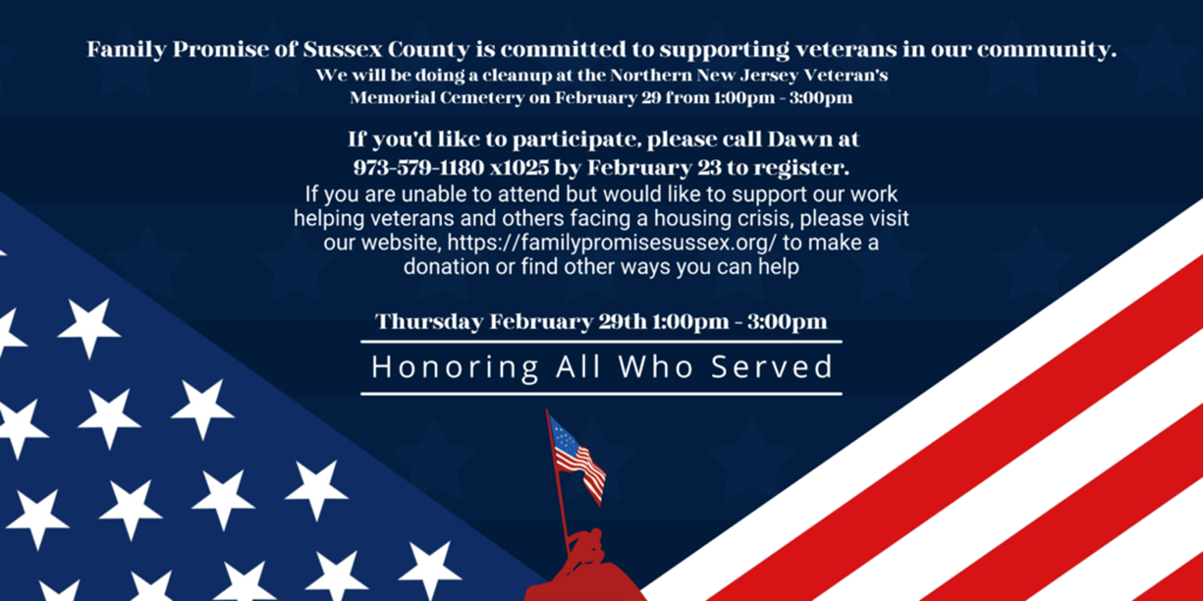
I will add them in closer to April, but for now you can check them out using this link.
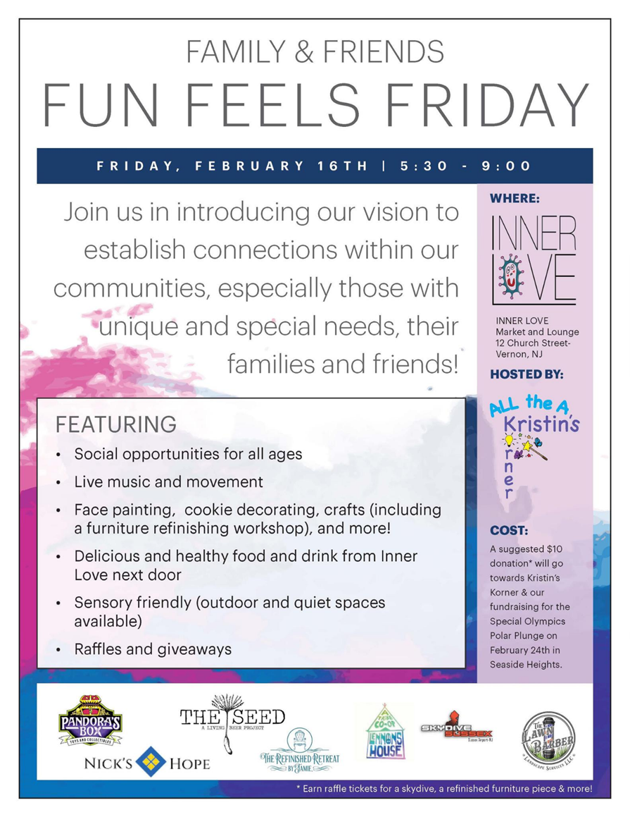

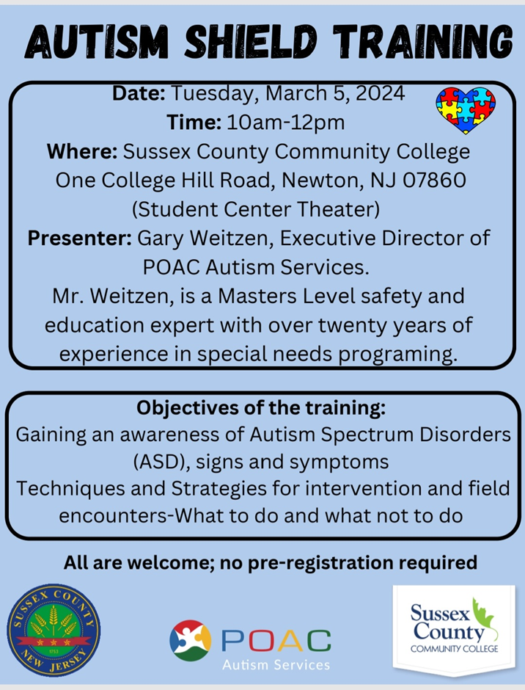
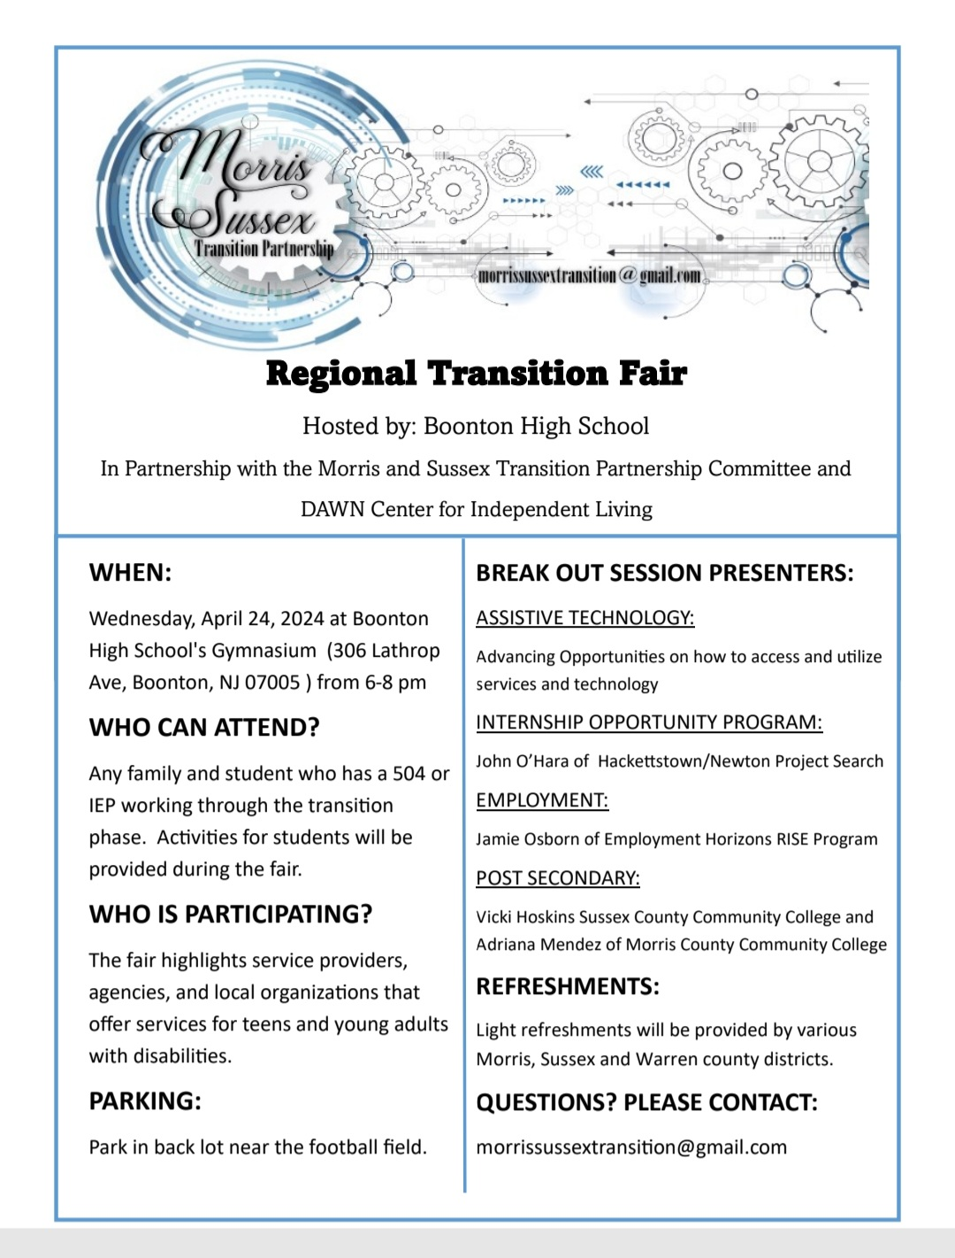

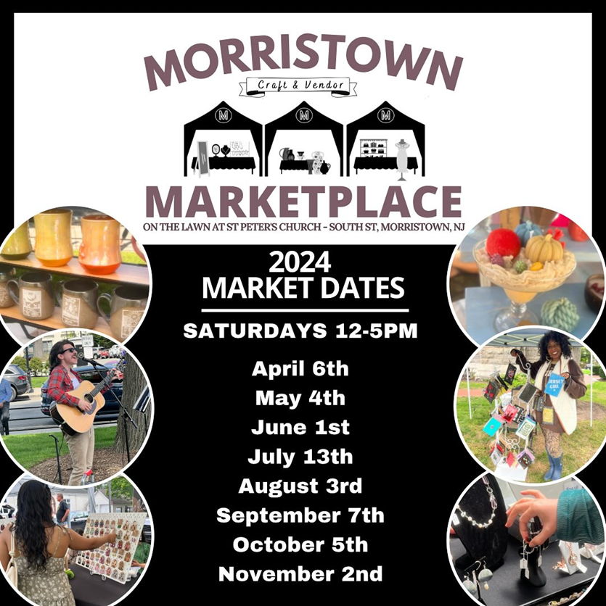

Happening Now @ PSS
In-person donations accepted Monday - Friday, 9am - 3pm.
​- Project Sussex Kids accepting applications for Parent/Caregivers & Community Organizations.
​- Bridges to Employing Youth enrolling Sussex County Young Adults Now.
​- New Jersey Youth Corps is taking new applicants. Enroll Now. Learn more at an Open House, Tuesdays at noon and Thursdays at 5pm, through February 15.
​- Utility Assistance is Available - Learn more.
​- Career Fair, April 17, 10am.
