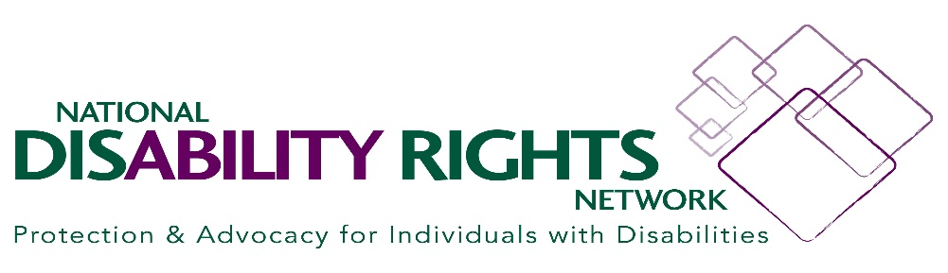.

MASKS AND OTHER COVID SAFETY CONCERNS
November 2020

Here are some resources re: how COVID safety issues impact students with disabilities.

In short, IDEA, Section 504, and the ADA all apply in mask cases involving students with disabilities in the same manner as they do in any other situation involving potential risks to health or safety. Bolding inside of quotes is added for emphasis.

A. Government Guidance

1) CDC

https://www.cdc.gov/coronavirus/2019-ncov/prevent-getting-sick/cloth-face-cover-guidance.html#feasibility-adaptations

“Feasibility and Adaptations

CDC recognizes that wearing masks may not be possible in every situation or for some people. In some situations, wearing a mask may exacerbate a physical or mental health condition, lead to a medical emergency, or introduce significant safety concerns. Adaptations and alternatives should be considered whenever possible to increase the feasibility of wearing a mask or to reduce the risk of COVID-19 spreading if it is not possible to wear one.
For example,
- People who are deaf or hard of hearing—or those who care for or interact with a person who is hearing impaired—may be unable to wear masks if they rely on lipreading to communicate. In this situation, consider using a clear mask. If a clear mask isn’t available, consider whether you can use written communication, use closed captioning, or decrease background noise to make communication possible while wearing a mask that blocks your lips.
- Some people, such as people with intellectual and developmental disabilities, mental health conditions or other sensory sensitivities, may have challenges wearing a mask. They should consult with their healthcare provider for advice about wearing masks.
- Younger children (e.g., preschool or early elementary aged) may be unable to wear a mask properly, particularly for an extended period of time. Wearing of masks may be prioritized at times when it is difficult to maintain a distance of 6 feet from others (e.g., during carpool drop off or pick up, or when standing in line at school). Ensuring proper mask size and fit and providing children with frequent reminders and education on the importance and proper wear of masks may help address these issues…
Masks are a critical preventive measure and are most essential in times when social distancing is difficult. If masks cannot be used, make sure to take other measures to reduce the risk of COVID-19 spread, including social distancing, frequent hand washing, and cleaning and disinfecting frequently touched surfaces.”

2) U.S. DOE Office of Civil Rights Guidance: Questions and Answers for K-12 Public Schools In the Current COVID-19 Environment (9/20)

https://www2.ed.gov/about/offices/list/ocr/docs/qa-covid-20200928.pdf

“Question 3: Under what circumstances must a school district waive a face covering requirement for a student with a disability?

Answer: In recent guidance, the Centers for Disease Control and Prevention (CDC) has advised school districts to address adherence to behaviors that prevent the spread of COVID-19 as a part of their reopening plans, including the appropriate use of cloth face coverings. The Department understands that using a face covering can be challenging for some students, teachers, and staff, especially those students with special educational or other healthcare needs. And in some instances, such as where a child with a disability has extreme sensory issues and cannot tolerate wearing a face covering in school or at all, OCR also recognizes that enforcing a face covering requirement could impede the child’s ability to receive the FAPE required by Section 504. School districts should therefore make reasonable modifications in their policies, practices, or procedures—including any addressing the use of face coverings—when those modifications can be made consistent with the health, safety, and well-being of all students and staff, and are necessary to avoid discrimination on the basis of disability.”

Protecting Staff
National Association of School Nurses' (NASN) Position Statement (last updated September 2020) for children with special health care needs returning to school.

NASN recommends that staff working in close proximity to the un-masked child wear appropriate face covering (cloth mask plus a face shield).

https://d28lcup14p4e72.cloudfront.net/245981/5569887/NASN%20Considerations_for_Post_COVID_Return_to_School_for_Students_with_.pdf

B. IN THE WILD:

Summary: Consider a combination of the following
- Additional space
- Additional PPE for staff (e.g. mask plus shield)
- Arranging desks and learning spaces to prevent overlap
- Smaller cohorts
- More of all of the safety protections already in place (Handwashing, disinfection, etc)
- Plexiglas barriers (Note: some districts do not permit student desk barriers)
- Mask breaks (Note: some districts do not permit mask breaks except for eating)
- “In home” only for certain higher risk activities like PE and chorus
- A face shield with a cloth drape

1) “District Administration” Newsletter

https://districtadministration.com/5-safety-measures-to-implement-for-students-who-cant-wear-masks/

1. Rearrange classroom seating arrangements.
Turn all the desks in the classroom to face the same direction, as opposed to having them face each other, Tedesco-Dallas says. Or seat all students on one side of a table, spaced apart, instead of using a circular table. Or, you can place physical barriers between student desks.

2. Implement mask breaks for all.
Let the students take off their masks for outside activities such as recess or socially distanced gym, Tedesco-Dallas says. This may help students who can wear a mask for short periods of time only.

3. Practice social distancing.
Where a mask isn’t possible, consider whether social distancing is. It’s difficult to socially distance on a bus, for example, but if you can, then it’s highly recommended when there’s a student on the bus who is unable to wear a mask. Some districts are asking parents to drive their students to school. That allows for more social distancing on buses because they are not filled to capacity as they would normally be, Tedesco-Dallas says.

4. Discuss options with parents.
“In terms of accommodations, a lot of the requests have been focused on face coverings,” Tedesco-Dallas says. If a parent requests an accommodation for his child with respect to a face covering, engage the parent and the student in a discussion. Then, document whatever reasonable accommodation will be placed in the student’s Section 504 plan. This is especially important if you have teachers or other staff members who are older and therefore in the vulnerable population more at risk for catching COVID-19.
“That could cause some issues,” Tedesco-Dallas says. “They [might] say, ‘We’re in a sensitive population, and that child is not wearing a mask.’ There needs to be some documentation as to why that child is not wearing a mask or cannot wear a mask.”

5. Keep in mind what’s practical.
“I think the bottom line is this all has to be implemented to the extent practical and possible,” Tedesco-Dallas says. “Sometimes, what’s recommended is not practical and possible, depending on what the setting is. It will take some creativity on the district’s part.”

2) Maine Case Example

“Our client was not allowed to attend school in person because she could not comply with the face-covering policies, though it was clear to all that she could only access her education in person. They had success in advocating for the district and private school placement to provide the reasonable accommodation of the Student using a Plexiglas desk barrier in the classroom (borrowed from the desks used for lunchtime). And, a goal around mask-wearing was added to the IEP. “

3) Policy Examples:

Oregon

https://www.oregon.gov/ode/students-and-family/healthsafety/Documents/Face%20Coverings%20and%20FAPE.pdf

OR recommends uses of the MDR Process

“Educational Decision-Making Based on the Team’s Determination
Lack of Face Covering or Face Shield IS Related to Disability or Medical Circumstances

If the team determines that the child is not wearing a face covering or face shield because of their disability or medical circumstances, the appropriate team must:
● Ensure the child is not excluded because of their medical condition or disability. They may need additional accommodations (e.g., smaller cohorts with additional physical space) to ensure ongoing access to FAPE.
● Determine how FAPE can be provided safely, which may include the provision of limited in-home services, subject to the conditions under in-person instruction for specific groups of students. Though IEP teams are always free to revisit placement determinations, no child’s placement can be made more restrictive due solely to their inability to wear a face covering or face shield.
● Review the student’s educational program and ensure that any needed changes (e.g., updates to accommodations, present levels, annual goals, or student supports) are appropriately made. “

New York City (attached)

“…If a student can medically tolerate a face covering but needs additional support towards compliance, the school should provide additional adherence support and additional breaks, explore the use of alternative personal protective equipment (PPE), and ensure other risk mitigation strategies such as handwashing and physical distancing are adhered to while the child progresses towards compliance. Students shall not be required to participate in remote-only instruction as they progress towards compliance.”

New York State (attached)
“…Determine whether there may be a valid reason for a student’s refusal to wear a mask. If a student indicates they cannot wear a mask or face covering due to a health or mental health condition, or a parent/guardian indicates such on their behalf, ensure that the student is distanced at least six to twelve feet away from other students and staff, depending on the current activity. Contact the school nurse, medical director, or administration for further direction. School policies need to be explained to parents, so they are aware of any additional documentation that needs to be provided, or whether other alternatives are available based on the student’s needs, including disability-related needs. Communication should be in the parents’ preferred language, and interpretation should be made available upon request.”

California

https://www.cde.ca.gov/ls/he/hn/strongertogethehealth.asp
“…Face coverings are not recommended for anyone who has trouble breathing or is unconscious, incapacitated, or otherwise unable to remove the covering without assistance. LEAs should make reasonable accommodations such as a face shield with a cloth drape for those who are unable to wear face coverings for medical reasons. Per Cal/OSHA, considerations for face shields should include a cloth drape attached across the bottom and tucked into shirt…”

