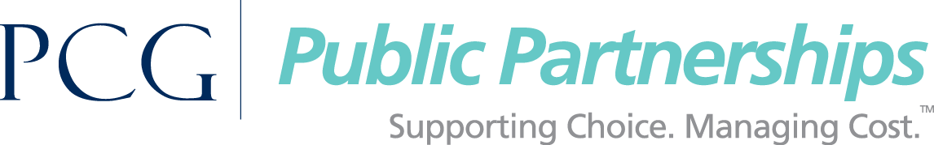

Contact: Stacey Ehling, 609-408-2461, Stacey@PrincetonSC.com

Editor’s Note: NJ is one of the first U.S. States to benefit from the “Care for Frontline Heroes” initiative.

For Immediate Release

PPL Partners with CARE to Thank NJ’s Frontline Home Care Providers
for the Elderly, Developmentally Disabled and Veterans

Princeton, N.J./Boston Mass. -- Frontline in-home workers who provide care and assistance for some of New Jersey’s most vulnerable residents, the elderly the developmentally disabled and veterans, will receive a special “Thank You” gift to provide some relief from the stresses of the COVID-19 pandemic.
Public Partnerships, LLC (PPL), a Public Consulting Group, Inc. company, has teamed up with CARE, the international relief organization, to offer a $25 CARE Package Gift Mastercard® to some 20,000 unsung heroes who provide needed daily assistance, care and support to help people live independently and remain in their communities.
The gift card offer extends to all workers in the New Jersey Personal Preference Program (PPP) the Department of Developmental Disabilities (DDD) Self-Directed Program, and the Division of Aging Services (DoAS) that administers the Jersey Assistance for Community Caregiving (JACC) and the Participant-Employed Provider (PEP) programs – jointly known as the JACC Program. These self-directed programs serve more than 22,000 New Jersey residents each year.
Public Partnerships started notifying eligible caregivers this week about the gift cards and more than 4,000 have already responded.
The gift cards are made possible by support from PPL, and other corporate sponsors, who have joined the new CARE “Care for Frontline Heroes” initiative to provide assistance in states, like New Jersey, that have been the hardest hit by the COVID-19 pandemic. CARE has been on the frontlines of disaster response and humanitarian aid for the past 75 years, but this marks the first time in the organization’s history that the United States is included in the list of countries requiring support.
“The Coronavirus is presenting unprecedented challenges to those in need of everyday care and support. We are extremely proud to be working with CARE to deliver iconic CARE Packages during this time,” said PPL Chief Executive Officer John Shaughnessy. “We sincerely hope this effort not only recognizes, but also brings some relief to those frontline caregivers.”
“CARE is proud to have been a leader in disaster response and humanitarian aid around the world for the last 75 years. Helping those most in need by taking on the world’s toughest challenges is the heart of who we are. And right now, that means tackling COVID-19 both here at home and abroad,” said Michelle Nunn, President and CEO of CARE. “Our brand-new CARE Package® is designed to meet this extraordinary moment by delivering support to today’s heroes: essential workers, frontline medical personnel, and caregivers; in addition to individuals in need, and communities around the world. The COVID-19 pandemic knows no borders – and neither does CARE’s work.”
The latest data shows New Jersey is currently ranked #2 in the U.S. for total number of COVID-19 cases which currently stands at 133,059, and there have been 8,572 deaths.
###

CARE is the leading humanitarian organization fighting global poverty by lifting up women and girls. It reached 68 million vulnerable people in 100 countries around the world in 2019. Since the onset of COVID, CARE has pivoted its life-saving food security, health services, educational, and women’s empowerment programming to directly fighting the spread and impact of the disease. As of April 17th, 2020, CARE has reached 107.4 million people with COVID-specific or adapted programs. 1.9 million people have been directly reached with hygiene messaging, 601,000 with hygiene kits, 773,000 with increased water, 114,000 with food or cash/vouchers and 22,800 with handwashing stations. To learn more about the CARE Package® please visit: www.carepackage.org.
PPL delivers Financial Management Services (FMS), which make sure the self-directing home care participants in the New Jersey PPP, DDD and JACC programs receive daily care and support from in-home caregivers, thus enabling them to stay and live in their communities and self-direct their own long-term care. To learn more about PPL, please visit www.publicpartnerships.com

Public Consulting Group, Inc. (PCG) is a leading public sector solutions implementation and operations improvement firm that partners with health, education, and human services agencies to improve lives. Founded in 1986 and headquartered in Boston, Massachusetts, PCG has over 2,000 professionals in more than 50 offices across North America and in Europe. The firm has five designated practice areas with extensive experience in all 50 states, clients in six Canadian provinces, and a growing practice in Europe. Often combining resources from two or more practice areas, PCG offers clients a multidisciplinary approach to solve their challenges or pursue opportunities. To learn more, visit www.publicconsultinggroup.com.

