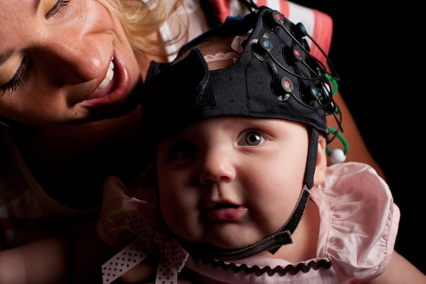
Attention Parents and Adults!

University of Delaware’s Move to Learn Lab

is conducting the UD Infant fNIRS Study
Principal Investigator: Anjana Bhat, PT, PhD

You are invited to participate in a study that examines brain activity as infants play with their caregivers and/or toys.

WHO CAN PARTICIPATE?
- Typically developing infants between 3 and 12 months
- Infant siblings of children with ASD between 3 and 12 months
- Preterm infants (< 37 weeks of gestation) between 3 and 12 months (corrected age)

WHAT WILL BE INVOLVED?
- This study will involve 4 testing visits completed at 3, 6, 9, and 12 months. All visits will be completed in our lab at the UD STAR Health Sciences Complex. Each session lasts about 1 hour.
- Prior to participation in the study, older sibling with autism will need to provide a letter from a pediatrician, psychologist, or psychiatrist confirming their autism diagnosis.
- At each visit, we will place a cap with LED lights on your and your infant’s head. Using fNIRS to capture brain activity during different tasks is a completely safe and non-invasive approach.
- You will be asked to play with your infant (face-to-face or with small toys) as you normally do at home.
- We will also ask you to fill out a standardized questionnaire that will assess your infant’s motor, social, and cognitive skills.
- We will also assess your infant’s developmental skills using a standard assessment.
- All testing sessions will be videotaped so that we can score the tests later. At the end of each visit, you will receive $25 for your infant’s participation. You are not separately compensated.

You can help by volunteering for our study. Please email the study PI, Dr. Bhat at: abhat@udel.edu (preferred) or call the Move to Learn - Autism Lab at 1-302-831-7608.
UD Infant fNIRS Study  1-302-831-7608  abhat@udel.edu | UD Infant fNIRS Study  1-302-831-7608  abhat@udel.edu | UD Infant fNIRS Study  1-302-831-7608  abhat@udel.edu | UD Infant fNIRS Study  1-302-831-7608  abhat@udel.edu | UD Infant fNIRS Study  1-302-831-7608  abhat@udel.edu | UD Infant fNIRS Study  1-302-831-7608  abhat@udel.edu | UD Infant fNIRS Study  1-302-831-7608  abhat@udel.edu | UD Infant fNIRS Study  1-302-831-7608  abhat@udel.edu | UD Infant fNIRS Study  1-302-831-7608  abhat@udel.edu | UD Infant fNIRS Study  1-302-831-7608  abhat@udel.edu | UD Infant fNIRS Study  1-302-831-7608  abhat@udel.edu | UD Infant fNIRS Study  1-302-831-7608  abhat@udel.edu

